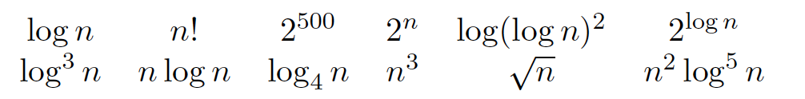

1. f(n) = \Theta (g(n))
2. f(n) = O(g(n)) or f(n) = o(g(n))
3. f(n) = \Omega(g(n)) or f(n) = w(g(n))
4. f(n) = \Omega(g(n)) or f(n) = w(g(n))
5. f(n) = \Theta (g(n))

2^500  < \log (\log n)^2 < \log n = \log_4 n < \log^3 n < n^0.5 < 2^(log n) < n\log n < n^2\log^5 n < n^3 < 2^n < n!